Doug Strouth

CIS228

City Jail Chapter 10

1)

SELECT CRIME_ID, CLASSIFICATION, DATE_CHARGED, HEARING_DATE, (HEARING_DATE-DATE_CHARGED)

FROM CRIMES

WHERE (HEARING_DATE-DATE_CHARGED) > 14;

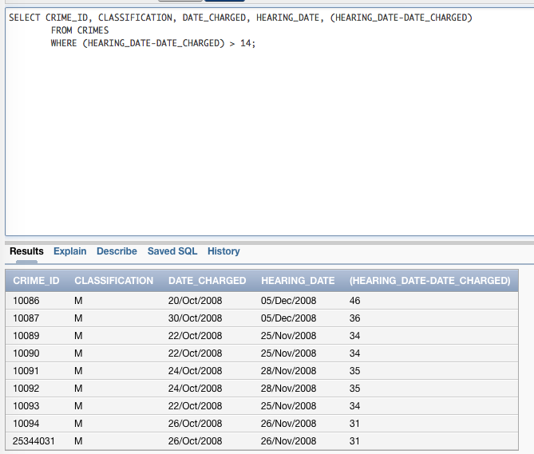

2)

SELECT PRECINCT,

CASE

WHEN PRECINCT LIKE '_A%' THEN 'SHADY GROVE'

WHEN PRECINCT LIKE '_B%' THEN 'CENTER CITY'

WHEN PRECINCT LIKE '_C%' THEN 'BAY LANDING'

ELSE 'NOT CURRENTLY ASSIGNED'

END "COMMUNITY ASSIGNMENT"

FROM OFFICERS

WHERE STATUS='A';

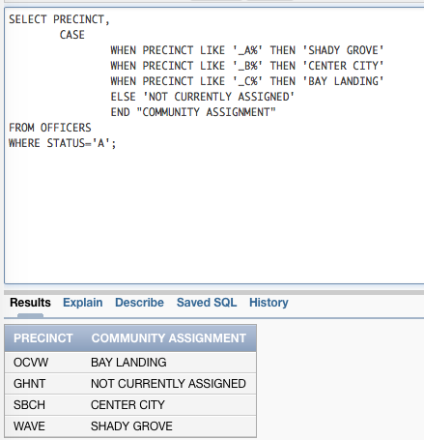

3)

SELECT C.CRIMINAL_ID, UPPER(C.LAST), UPPER(C.FIRST), S.SENTENCE_ID, TO_CHAR(S.START_DATE, 'MONTH DD, YYYY') AS "START DATE", ROUND(MONTHS_BETWEEN(S.END_DATE,S.START_DATE)) AS "LENGTH OF SENTENCE"

FROM CRIMINALS C, SENTENCES S

WHERE C.CRIMINAL_ID=S.CRIMINAL_ID;

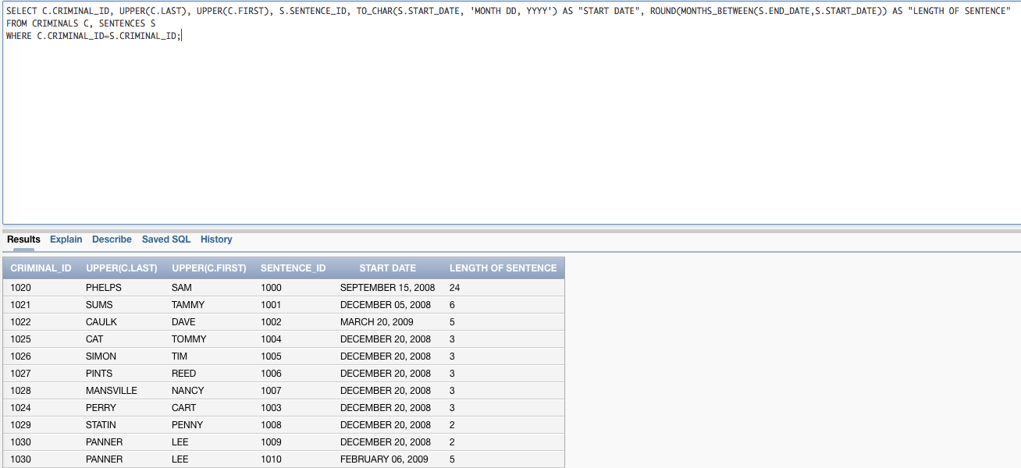

4)

SELECT LAST, FIRST, CHARGE_ID, TO_CHAR((FINE_AMOUNT+COURT_FEE), '$9999.99') AS "TOTAL AMOUNT OWED", TO_CHAR(AMOUNT_PAID,'$999.99') AS "AMOUNT PAID", TO_CHAR(((FINE_AMOUNT+COURT_FEE)-AMOUNT_PAID), '$9999.99') AS "AMOUNT OWED", PAY_DUE_DATE AS "PAY DUE DATE"

FROM CRIMINALS NATURAL JOIN CRIMES NATURAL JOIN CRIME_CHARGES

WHERE ((FINE_AMOUNT+COURT_FEE)-AMOUNT_PAID) >0;

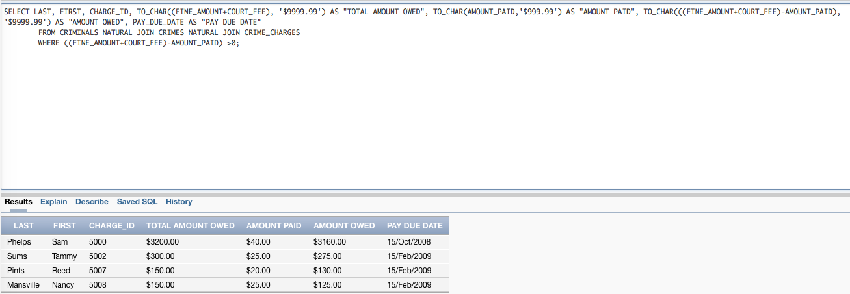

5)

SELECT C.LAST, C.FIRST, S.START_DATE, ADD_MONTHS(START_DATE, 2) AS "PROBATION REVIEW HEARING"

FROM CRIMINALS C NATURAL JOIN SENTENCES S

WHERE TYPE='P'

AND MONTHS_BETWEEN(END_DATE,START_DATE) > 2;

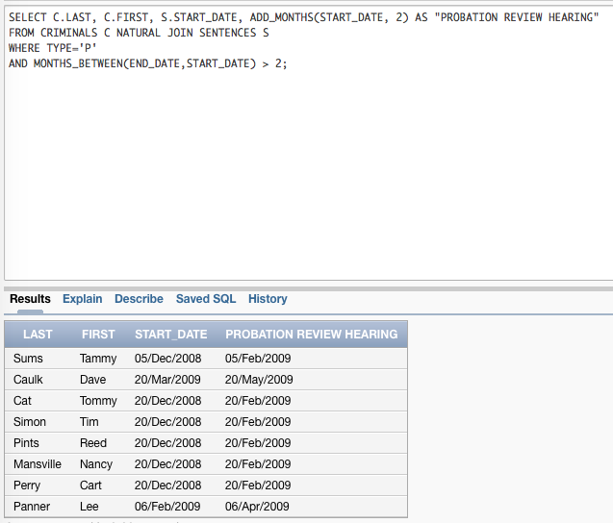

6)

INSERT INTO APPEALS (APPEAL_ID,CRIME_ID, FILING_DATE, HEARING_DATE)

VALUES (APPEALS_ID_SEQ.NEXTVAL, :CRIME_ID, TO_DATE(:FILING_DATE, 'MM DD YYYY'), TO_DATE(:HEARING_DATE, 'MM DD YYYY'));

